**FLOW ASSURANCE PROJECT**

TO

Dr. Kondapi

**Group-5**

Nazmul Hossain

Sai Sandeep

Don Banineaux

Mahesh Reddy

CONTENTS

1 Executive Summary 4

2 Field Architecture and Flow Assurance Strategy 4

2.1 Field Architecture 4

2.2 Flow assurance strategy 5

2.2.1 Hydrate Formation 6

2.2.2 Wax 8

2.2.3 Asphaltene 9

2.2.4 Corrosion 11

2.2.5 Erosion Corrosion 12

2.2.6 Slugging 14

2.2.7 Water Injection 15

3 Input data and Assumptions made 15

4 Modeling and Analysis approach/methodology 16

4.1 PIPESIM 16

4.2 Overall approach 18

4.2.1 Pressure Drop in Tubing, Flowline, and Riser 18

4.2.2 Production and Injection Choke Pressure Drop 19

4.2.3 Thermal Losses 19

4.2.4 Erosional Study 19

4.2.5 Gas Lift Study 19

4.2.6 Liquid Slugging 19

5 Analysis Results 19

5.1 Early Life Analysis 19

5.2 Mid Life Analysis 22

5.3 Late Life Analysis 25

6 Recommendations 27

7 References 28

Figure 1. Field layout with flowline Measured distances 4

Figure 2. Mixture Fluid Phase Diagram 16

Figure 3. Single well analysis layout in Pipesim 17

Figure 4. Production well analysis layout in Pipesim 17

Figure 5. Water injection well analysis layout in Pipesim 17

Figure 6. Chemical injection well analysis layout in Pipesim 18

Figure 7. Production Wells Pressure vs Total Distance 20

Figure 8. Production Wells Temperature vs Total Distance 20

Figure 9. Production Well Erosional Velocity Ratio vs Total Distance 21

Figure 10. Production Well Fluid Mean Velocity vs Total Distance 21

Figure 11. Water Injection Well Pressure vs Total Distance 22

Figure 12. Production Wells Pressure vs Total Distance 23

Figure 13. Production Wells Temperature vs Total Distance 23

Figure 14. Production Well Erosional Velocity Ratio vs Total Distance 23

Figure 15. Production Well Fluid Mean Velocity vs Total Distance 24

Figure 16. Water Injection Well Pressure vs Total Distance 25

Figure 17. Production Wells Pressure vs Total Distance 25

Figure 18. Production Wells Temperature vs Total Distance 26

Figure 19. Production Well Erosional Velocity Ratio vs Total Distance 26

Figure 20. Production Well Fluid Mean Velocity vs Total Distance 26

Figure 21. Water Injection Well Pressure vs Total Distance 27

Table 1. Summary of flowlines used in Production 5

Table 2. Summary of flowline used in Water injection 5

Table 3. Calculated reservoir pressure used in Production wells 15

Table 4. Calculated FBHP used in Injection wells 15

Table 5. Data from Pipesim simulation at early life production wells 22

Table 6. Data from Pipesim simulation at early life production wells 24

Table 7. Data from Pipesim simulation at early life production wells 27

# Executive Summary

Field layout of five production wells and four water injection well was analyzed applying Flow Assurance strategies using Pipesim steady state simulation tool. Various Flow Assurance issues (Hydrate/Wax formation, erosion, liquid slugging etc.) were investigated and possible solution (Optimized line sizing, choking, thermal insulation, chemical injection, gas-lift etc.) analyzed in this project.

# Field Architecture and Flow Assurance Strategy

## Field Architecture

Figure 1 shows the recommended placements of the manifolds, pipelines, and the FPSO. Field layout was done condiering the offset distance to minimize cost.

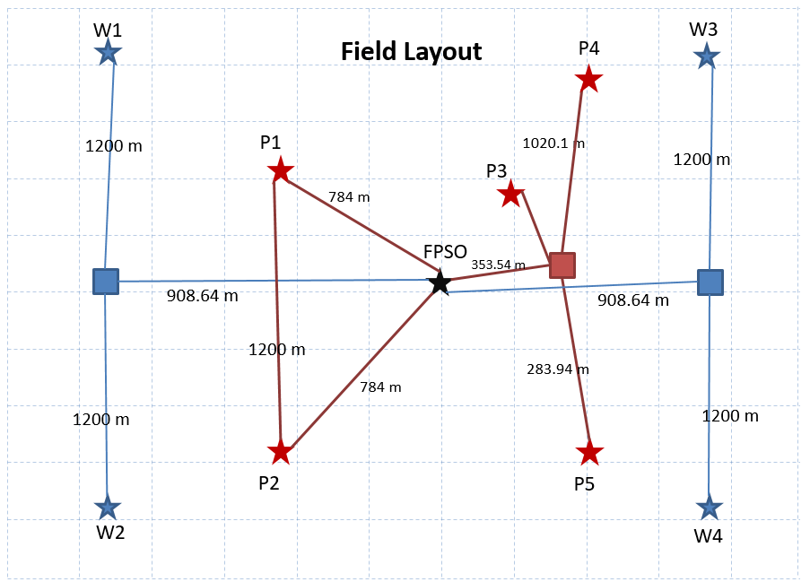

M1

Production Manifold

Water Injection Manifold

Production Flowline

Water Injection Flowline

Production Well

Water Injection Well

Figure 1. Field layout with flowline Measured distances

Table . Summary of flowlines used in Production

|  |  |  |  |  |  |  |
| --- | --- | --- | --- | --- | --- | --- |
| Fllowlines | Horizontal distance | Elevation | Undulation | ID | Roughness | U-value |
| M1RB | 2231.08 | -246.063 | 10 | 6 | 0.0018 | 0.2 |
| P1RB | 2562.281 | -223.976 | 10 | 4.5 | 0.0018 | 0.2 |
| P2RB | 2562.281 | -223.976 | 10 | 4.5 | 0.0018 | 0.2 |
| P3M1 | 1856.191 | -164.042 | 10 | 4.5 | 0.0018 | 0.2 |
| P4M1 | 3937.008 | 0 | 0 | 4.5 | 0.0018 | 0.2 |
| P5M1 | 1312.336 | 0 | 0 | 4.5 | 0.0018 | 0.2 |
| Riser | 112.469 | 3854.987 |  | 12 | 0.0018 | 0.2 |

Table . Summary of flowline used in Water injection

|  |  |  |  |  |  |
| --- | --- | --- | --- | --- | --- |
| Fllowlines | Horizontal distance | Elevation | Undulation | ID | U-value |
| M1W1 | 3937.008 | 0 | 0 | 4.5 | 0.2 |
| M1W3 | 3937.008 | 0 | 0 | 4.5 | 0.2 |
| M2W2 | 3937.008 | 0 | 0 | 4.5 | 0.2 |
| M2W4 | 3937.008 | 0 | 0 | 4.5 | 0.2 |
| RBM1 | 2952.614 | 410.105 | 10 | 4.5 | 0.2 |
| RBM2 | 2952.614 | -410.105 | 10 | 4.5 | 0.2 |
| Riser | 196.66 | 3854.987 |  | 12 | 0.2 |

## Flow assurance strategy

Two manifolds were chosen to distribute the water injection to wells W1-4, and were placed in such a way to minimize flowline lengths and thus frictional pressure loss. The advantage of using two smaller manifolds over using one large manifold only includes ease of handling, requirement for smaller rigs, and overall, to reduce costs. The same principle was applied to select the amount and locations for the production manifolds. Only one production manifold is used in our selected field architecture. Flowline connecting P1 and P2 is only for pigging operation.

In order to ensure flow of oil and gas from the reservoir to the topside over the entire field life-cycle, several flow assurance strategies were implemented. As an overall flow assurance strategy, we recommend avoiding artificial gas lift as much as possible and controlling the fluid mean velocity below erosionall velocity using chokes and suitable tubing diameter. This way, we can decrease costs and challenges such a liquid slugging.

### Hydrate Formation

Hydrates are crystalline water structures with low molecular weight gases as guest. In other words, gas hydrates are a 3-dimensional network of different type of cages and gas molecules stabilize cages made of water molecules. Hydrates to be formed all of the following conditions need to be satisfied.

* Presence of small molecules in the stream such as C1, C2, C3, I-C4,CO2, H2S, N2
* Access to free water. condensate water is also enough
* High enough pressure. Hydrates can be stable at 10 – 15 bars.
* Low enough temperature

Hydrate problems can appear during normal production, but transient operations are often more vulnerable. For instance, during a shut-down, the temperature of the subsea pipeline drops to that of the surrounding environment. Given sufficient time under these high pressures and low temperatures, hydrates will form.

#### Hydrate prevention

Techniques to prevent hydrate formation in subsea systems are given below:

Inhibitors: hydrate inhibitors are added in batch treatment for the process of start-up, shut-down, or continuously injected when there is induced cooling probable because of choking and natural cooling of pipeline by the cold ambient temperatures of the seabed. There are two main chemical categories which inhibit hydrate formation.

Thermodynamic inhibitors: the most common method of hydrate prevention in subsea system and deep water development is injection of thermodynamic inhibitors. Thermodynamic hydrate inhibitors lower hydrate formation temperature and moves hydrate curve to the left decreasing the hydrate formation domain. Methanol and glycols (MEG, DEG, and TEG) are both effective inhibitors if sufficient quantities are used. Some electrolytes (salts) are used as thermodynamic inhibitors.

Thermodynamic hydrates inhibitors are used in wells, flowlines/risers, and process systems in start-up, shut-down, remediation and continuous operation. Thermodynamic inhibitors are used in both gas and oil and widely approve and used but high volumes of inhibitors are required

**Low dosage hydrate inhibitors (LDHIs):** LDHIs are divided into two categories of kinetic inhibitors and anti-agglomeration inhibitors. Kinetic inhibitors delay hydrate formation and delay hydrate formation and inhibit hydrate crystal growth. The amount of this type of inhibitor is independent of water-cut, but has low allowable sub-cooling. It can be used in both oil and gas streams. The mechanism of anti-agglomeration inhibitors is that this type of inhibitor allows hydrate formation but it controls hydrate particle size. It is only effective when water cut is below 50% and it is used for oil and condensate. LDHIs can be effective at much lower dosage than thermodynamic inhibitors such as methanol and MEG, but they do not work by preventing hydrates from forming. They typically are effective when temperature drops more than 10 °C below hydrate formation temperature.

**Low pressure operation:** it is referred to maintaining the system pressure corresponds to the ambient temperature based on the hydrate dissociation curve. For deep water for an ambient temperature of 40 ˚F, the pressure may need to be 300 psi or less. Keeping production flowline in lower pressure (by choking), the difference between hydrate dissociation and operating temperatures is reduced. The lower sub-cooling will decrease the driving force for hydrate formation.

**Water removal:** dehydration, water removal, is a common hydrate prevention method applied to export pipelines. Subsea separation systems can reduce water flow in subsea flowlines. As a new technology, subsea water separation/disposal systems are designed to separate bulk water from the production stream close to subsea trees on the seafloor.

**Insulations:** Insulation provides hydrate control by maintaining temperatures above hydrate formation conditions. Insulation also extends the cool-down time before reaching hydrate formation temperatures. The cool-down time gives operators time either to recover from the shutdown and restart a warm system or prepare the system for a long-term shutdown. Insulation is generally not applied to gas production systems, because the production fluid has low thermal mass and also will experience JT cooling. For gas systems, insulation is only applicable for high reservoir temperatures and/or short tie-back lengths.

**Active heating:** Active heating includes electrical heating and hot fluid circulation heating in a bundle. Advantages of electrical heating include eliminating flowline depressurization, simplifying restart operations, and providing the ability to quickly remediate hydrate blockages. Electrical heating techniques are direct heating using flowline as an electrical conductor for resistance heating and indirect heating, using an electrical heating element installed on the outer surface of flowline.

Hot fluid circulation heating in a pipe bundle is another techniques used in subsea systems which has many of the same advantages as electrical heating. Instead of using electricity hot fluid, typically inhibited water circulates in the bundles to provide heat to the production fluids.

#### Hydrate Remediation

The dissociation behavior of hydrate depends on the hydrate size, porosity, permeability, volume of occluded water, “age” of the deposit, and local conditions such as temperature, pressure, fluids in contact with the plug, and insulation layers over the pipeline. Although the design of a unit is intended to prevent hydrate blockages, industry operators must include design and operational provisions for remediation of hydrate blockages. A hydrate blockage remediation plan should be developed for a subsea system where hydrate formation is an issue. The plan will be a guidance to the operators how to locate when a blockage might be occurring and what to do about it. Hydrate remediation techniques are similar to hydrate prevention techniques, which include:

1. Depressurization from two sides or one side, by reducing pressure below the hydrate formation pressure at ambient temperature, will cause the hydrate to become thermodynamically unstable.
2. Thermodynamic inhibitors can essentially melt blockages with direct hydrate contact.
3. Active heating is used to increase the temperature to above the hydrate dissociation temperature and provide significant heat flow to relatively quickly dissociate a blockage.
4. Mechanical methods such as drilling, pigging, and scraping have been attempted, but are generally not recommended. Methods include inserting a thruster or pig from a surface vessel with coiled tubing through a workover riser at launchers, and melting by jetting with MEG.
5. Replace the pipeline segment [0,2].

At the current temperature profile, hydrates may form at P3 and P4. In order to mitigate or prevent the formation of hydrates in those wells, we recommend the use of hydrate inhibitors. More severe prevention methods will be required for mid-to-late life as the water cut increases from 10% to 40 and 90%, respectively, and the increased water content in the flowline will encourage hydrate formation.

### Wax

#### Introduction/Background

Wax in pipelines assumes the inclusion of both crude wax and paraffin, which when deposited consists of small wax crystals that can agglomerate into larger particles. Wax are mostly long chain n-alkanes and compose 1-15% weight of crude oil. Any paraffin present may in addition include gums, resins, water, etc. The consistency of the deposited wax may range from soft to firm, depending on the amount of oil [reister]. The point below which wax crystals begin to form is called the cloud point (80 F for this field). As crystals form, they may be carried by the fluids, or be deposit and build up on a cold surface. As deposition and gelling becomes more severe due to temperature, the fluid reaches the pour point, which is the point at which flow stops and gels. Wax formation can thus be characterized by cloud and pour point analysis. While temperature is a major determining factor in wax formation, fluid flow is also important. The flow of oil can provide enough shear force to destroy the intermolecular structure of gels. Thus high production rates can be useful in mitigating wax deposition [0].

The main presentations of wax problems during operation are gelling and deposition. Most commonly, wax deposits on oil coolers in the topside. Other problems include wax accumulation in storage tanks, gelling in flowlines, etc. One way in which wax deposits in pipewalls is through molecular diffusion. Since the outer areas of the pipe lumen are cooler, wax tends to form there. Some of the key issues that flow assurance analysis should address includes [0]:

* Deposition in flowlines that may lead to reduced production or blockage
* Gelation during shut-in
* High start up pressures due to higher viscosity
* Increased expenses due to need for insulation
* Increased expenses due to need for inhibitors
* Scheduling for pigging operation
* Handling of wax at topsides

#### Available methods of wax control

Lab analysis (e.g. cold finger test) of reservoir oil samples will provide a better picture of the characteristics of the wax behavior for the particular reservoir. From the analysis, more specific wax control methods can be implemented. Methods of wax control involve thermal, mechanical and chemical techniques, such as the following [2, 0]:

* **Thermal:** Pipe insulation, such as coating or pipe-in-pipe systems, bundles, electric heating, hot oil flushing. One “rule of thumb” is to set the deposition temperature 15 F above the cloud point [0]. All of these methods aim to keep the heat inside the pipe high so that wax does not precipitate.
* **Mechanical:** Pigging (as a prevention and remediation process, a pipeline will require regular pigging or else severe build up will make pigging impossible), coiled tubing
* **Chemical:** Inhibitors (thermodynamically suppress cloud point, viscosity and pour point), dispersants, dissolvers

#### Wax control strategy

From PIPESIM simulations of the recommended flowline system, the use of flowline and riser insulation (0.1-0.2 BTU/ft2/s) was sufficient to keep the oil and gas from reaching wax formation temperature (80 F) at wells P1, P2, and P5. Wells P3 and P4 drop below the cloud point and can pose wax formation problems. In order to prevent wax formation at those wells, an injection of chemical inhibitors downhole near the perforations will be required to prevent wax deposition. Regular pigging along the flowlines of P3 and P4 will also minimize the effects of wax deposition. Currently, the system operates on single flowlines; in order to permit pigging, dual flowlines will be required. More details are discussed in Section 6.

### Asphaltene

Asphaltenes are of large molecule of polyaromatic and heterocyclic aromatic rings with side branching in crude oil and black in color. Asphaltenes are polar compounds soluble in aromatic solvents such as toluene while insoluble in n-heptanes. A certain amount of asphaltene can be found in all oils and carries the bulk of inorganic component, including sulfur, nitrogen, and metals such as nickel and vanadium. During production asphaltene problem arises when it becomes unstable. Asphaltene stability depends on the ratio of asphaltene to the stabilizing factors such as aromatics and resins as well as to the reservoir pressure which has the highest impact.

Asphaltenes are typically stable under virgin reservoir condition, which are believed to be held in solution by resins. During production, asphaltenes can be destabilized and precipitate due to changes pressure, temperature (to a lesser extent) and the chemical composition of the crude. Asphaltene becomes unstable as well pressure decreases and volume fraction of aliphatic components increases. When the aliphatic components reaches to a threshold limit, it begins to flocculate and precipitate and the pressure at which this occurs is called the flocculation point [0]. In addition to normal pressure decline, acid stimulation, gas lift operations, miscible flooding are conducive factors of asphaltene precipitation [0].

Asphaltene precipitation is a recurrent problem in production and refining of crude oils. To avoid precipitation, it is useful to know the solubility of asphaltenes in petroleum liquids as a function of temperature, pressure, and liquid-phase composition. Researchers [3] have used a molecular thermodynamic framework model to describe phase behavior of asphaltene containing fluids. Using this model, the onset of asphaltene precipitation of the medium and the total amount of precipitation at the given condition can be obtained.

To assess the asphaltene problem, an oil sample from reservoir needs to be characterized and saturates, aromatics, resins, and asphaltene are analyzed. This analysis determines the stability of asphaltene by identifying the amount of those four components, also called pseudo-components. The ratio of saturates to aromatics and asphaltenes to resins is computed and used to determine the stability of the oil.

Asphaltene problem becomes most probable when pressure passes the bubble point and the deposition often occurs in the tubing. It also can damage the formation plugging the pores’ throat in vicinity of downhole casing and tubing. To mitigate asphaltene precipitation, inhibitors are usually injected bottomhole.

Since direct intervention with cold tubing is associated with highly cost in subsea wells, the strategies that have been proposed to minimize asphaltene deposition are given below:

* Continuous injection of an asphaltene dispersant into wellbore,
* Installment of an equipment to facilitate periodic injection of an aromatic solvent into the wellbore for a solvent soak to be considered,
* To remove an occurred deposit be prepared financially and logistically.
* Use pigging along with solvents to control the asphaltene deposition. Extra umbilical line would be required to deliver asphaltene dispersant immediately above the packer employing this strategy.

Flow assurance modeling helps to understand pressure profile in subsea systems especially where the bubble point is reached and because bubble point is least stable point for asphaltene, deposition problems can be expected to be worst at this point [0].

### Corrosion

Corrosion and material degradation is one the major problems in oil and gas industries. Marine corrosion is encountered in structures which are in contact with sea water. Structures such as offshore platforms and rigs, ships, port infrastructures to name a few will be vulnerable to marine corrosion.

Subsea pipelines can be threatened by corrosion externally and internally. External corrosion of pipeline is occurred due to anodic reaction of metal with seawater. Presence of oxygen adds extra cathodic reaction to the reduction reactions leading to increase in the corrosion rate. Since dissolved oxygen in water reduces as the depth increase, therefore, corrosion rate decreases even though other parameters such as temperature, flow velocity influence the corrosion rate. To battle the external corrosion in subsea systems, proper material selection in design stage is considered in addition to coating and cathodic protection.

#### Internal corrosion of subsea equipment and pipelines:

Oil and gas coming out of the underground geological formations is accompanied with byproducts such as water, carbon dioxide (CO2) and hydrogen sulfide (H2S), as well as various salts and organic acids. Carbon dioxide and hydrogen sulfide gases are called acid gases. Combination of water and acid gases provide a corrosive environment which influences the integrity of pipelines.

Several forms of corrosion occur in the oil and gas fields. CO2 corrosion (sweet corrosion) and H2S corrosion (sour corrosion) of production fluid wetted surfaces as well as corrosion due to presence of oxygen in water injection systems are considerably the most common forms of corrosion that threat the oil and gas production equipment and transformation pipeline. CO2 corrosion is the cause of the majority of oilfield failures mainly due to the lack of knowledge/predictive models and the poor resistance of carbon and low alloy steels to this type of corrosion.

CO2 dissolves in water and produces carbonic acid which is a weak but corrosive acid. Also H2S dissociates to atomic hydrogen and S2- ion. S2- ions have poisoning effect and don’t let protons (H+) to combine and form hydrogen gas, consequently, protons are reduced to atomic hydrogen and atomic hydrogen can diffuse into the steel which can lead to hydrogen induced cracking.

Presence of CO2/H2S in production fluid and in combination with water can cause uniform internal corrosion, erosion corrosion especially in bends and tees, pitting and crevice corrosion. Also H2S can lead to sulfide stress cracking which is very pronounced.

Internal corrosion in subsea equipment and pipelines depends on the presence of water, concentration of CO2 and H2S gases (acid gases), pipe material, temperature, pressure, flow Regime, flow rates / velocities, Presence of sand increases the erosion corrosion. Pitting and crevice corrosion (localized corrosions) are other types of corrosion which occurs in oil and gas industries.

#### Pitting corrosion:

Inherent thin passive films formed on some of the engineering alloys such as stainless steels, aluminum alloy, and nickel alloys protect these alloys from corrosion. Such passive films however are susceptible to breakdown, resulting in accelerated dissolution of underlying metal. If the attack initiated in an open surface, it is called pitting corrosion and it occurs in an occluded site, it is called crevice corrosion.

Localized corrosion can lead to accelerated failure of structural components by perforation or by acting as an initiation site for cracking.

Pitting corrosion is influenced by many different parameters, including the environment, metal composition, potential, temperature, and surface condition. Important environmental parameters include aggressive ion concentration, pH, and inhibitor concentration [0].

#### Crevice corrosion:

Corrosion in blocked regions, crevices, is one of the most damaging forms of material degradation. Different engineering structures such as lap joints in aircraft, flanged pipes in chemical processing plants, metal surface under initially protective coatings all have an occluded solution. Crevice corrosion occurs when a wetted metallic surface is in close proximity to another surface. The average separation between (gap, g) between the two surfaces is between 0.1 – 100 µm. For some material/environment combinations, this geometric arrangement can lead to accelerated attack of the metal surface. Mitigation of crevice corrosion can be done by proper design and material selection as well as using inhibitors [6].

### Erosion Corrosion

Erosion corrosion (E/C) refers to the simultaneous, synergistic interactions between solid particle erosion (SPE) and corrosion. Most metals exposed to a moving liquid are susceptible to erosion-corrosion under specific conditions. Examples include piping systems, particularly at bends, elbows, or wherever there is a change in flow direction or increase in turbulence; pumps; valves, especially flow control and pressure let-down valves; centrifuges; tubular heat exchangers; impellers; and turbine blades. Surface films that form on some metals and alloys are very important in their ability to enhance resistance to liquid erosion-corrosion [7].

Erosion is not a common reason for pipeline failures in subsea systems. However, for high velocity fluid containing sand particles, erosion could occur, especially at bends, reduced diameters, and where pipeline connections or other geometrical details are present. Liquid velocity is usually limited because of erosion effects at fittings. Erosion damage can occur in flowlines with multiphase flow because of the continuous impingement of high-velocity liquid droplets. The damage is almost always confined to the place where the flow direction is changed, such as elbows, tees, manifolds, valves, and risers. The erosional velocity is defined as the bulk fluid velocity that will result in the removal of corrosion product scales, corrosion inhibitors, or other protective scales present on the inner surface of a pipeline.

Several empirical equations have been proposed to calculate the erosional velocities in pipeline. API 14E recommended equation which is for gas/liquid two phase flow is given below:

where,

Ve is fluid erosional velocity in ft/s;

ρm is fluid (gas-liquid) density (lb/ft3)

C is an empirical constant which is 100 for continuous services, 125 for intermittent services, 200-300 for corrosion resistance alloys if used.

API Equation doesn’t consider pipeline geometry and solid particle shape.

There are two primary mechanisms of erosion. The first is erosion caused by direct impingement which occurs in fittings that redirect the flow. The other mechanism is erosion caused by random impingement. This type of erosion occurs in the straight sections of pipe even though there is no mean velocity component directing flow toward the wall. These two mechanisms can cause different types of erosion based on the fluid compositions, velocity, and configurations of piping systems. Presence of solid particles, sand producing wells, exacerbates erosion corrosion. To predict erosion rate several models have been developed some of which has mentioned below.

* Huser and Kvernvold Model
* Salama and Venkatesh Model
* Svedeman and Arnold Model
* Shirazi et al. Model
* Tulsa ECRC Model

#### Mitigation of Erosion in Subsea Pipelines

A number of measures can be utilized to mitigate erosion corrosion:

* Reduction of Production Rate
* Design of Pipe System, Minimizing the flow velocity and avoiding sudden changes,
* Increasing wall thickness
* Appropriate erosion-corrosion resistant material selection [0]

### Slugging

Liquid slugging is a problem affecting primarily multiphase pipelines. When liquid and gas flow at the same time, the lower density of gas causes it to travel through the liquid towards the surface, while the liquid gets left behind. As the separation of gas and liquid becomes more severe, so much that there are sequences of gas and liquid traveling within the pipeline, a condition called slugging occurs. Some common causes of liquid slugging include [2]:

* 1. Low flow rate
  2. Production shut downs and restarts
  3. Low Gas-Oil Ratio
  4. High water cut
  5. Flow rate changes
  6. Transient conditions caused by changes in subsea operations
  7. Decreasing reservoir pressure/wellhead pressure

Based on the above causes, slugging can be classified into the following types:

1. Hydrodynamic slugs: As the stratified flow regime becomes unstable, gas and liquid may separate enough to form sequences of slugs. Accordingly, flows with large relative velocities between gas and liquid flow have a higher chance of forming hydrodynamic slugs.
2. Terrain-induced slugs: Pooling of liquid on downward joints (e.g. to accommodate downward sloping terrain) in the flowline can lead to periodic purging of the liquid in the form of slugs. During simulation it is important to include the undulations of the sea floor so that a more accurate prediction of terrain-induced slugging can be carried out.
3. Operationally induced slugs: Transient states of the fluids during shut in, start up, and pigging can cause accumulation of liquids and thus slugging.

Slugging can generate a multitude of mechanical problems from the flowline to the topsides. The amount of kinetic energy released upon the impingement of liquid slugs to a pipeline component can cause mechanical damage, fatigue, control instability, etc. The slug volume and lengths are also a key determining factor for topsides slug handling facilities (i.e. flooding may occur if slug volumes exceed slug catcher capacities) [0]. A potential source of slugging problems is the in riser base. For example, if a large volume of liquid hold up is present at the base due to insufficient gas velocity, the hold up may suddenly arrive at the topsides as a large, high velocity liquid slug. In order to reduce the chances of this happening, it is recommended to have a slight upward inclination (2 – 5 degrees) of the connection between the seafloor flowline and riser. On the other hand, a downward slope of the flowline immediately prior the riser base will encourage such severe slugging [0]. As seen in Figures 1 and 2, the arrival of the flowline from M1 to the riser base is on a declining slope, which can encourage severe riser slugging. Aside from recommending an alternate design using steel catenary risers, a mitigation strategy will be to include a slug catcher on the FPSO. Based on the analysis results as seen in Section 5, the slug catcher should have a capacity of 1500 ft3. A processing facility can be placed at the riser base to catch slugs and separate liquid and gas to two different risers [0], but such an arrangement may not be economic.

### Water Injection

To maintain reservoir pressure, water injection was considered.

# Input data and Assumptions made

As API is 19, the fields are producing heavy oil. Downhole pressure is considered equivalent to bottomhole pressure. Reservoir pressure for production and FBHP for water injection are calculated using follwoing:

Table . Calculated reservoir pressure used in Production wells

|  |  |  |  |  |  |  |  |  |  |
| --- | --- | --- | --- | --- | --- | --- | --- | --- | --- |
|  | early life | | | mid life | | | late life | | |
| **Well** | **Q** | **P(reservoir)** | **Adding Watercut(10%)** | **Q** | **P(reservoir)** | **Adding Watercut(50%)** | **Q** | **P(reservoir)** | **Adding Watercut(80%)** |
|  | bopd | psia | psia | bopd | psia | psia | bopd | psia | psia |
| P1 | 14600 | 3930 | **4367** | 4000 | 3400 | **6800** | 2000 | 3300 | **16500** |
| P2 | 12300 | 3815 | **4239** | 4500 | 3425 | **6850** | 1200 | 3260 | **16300** |
| P3 | 6300 | 3515 | **3906** | 1700 | 3285 | **6570** | 800 | 3240 | **16200** |
| P4 | 8500 | 3625 | **4028** | 3500 | 3375 | **6750** | 1800 | 3290 | **16450** |
| P5 | 15000 | 3950 | **4389** | 7000 | 3550 | **7100** | 2500 | 3325 | **16625** |

Table . Calculated FBHP used in Injection wells

|  |  |  |  |  |  |  |
| --- | --- | --- | --- | --- | --- | --- |
|  | early life |  | mid life |  | late life |  |
| **Well** | **Q** | **FBHP** | **Q** | **FBHP** | **Q** | **FBHP** |
|  | bopd | psia | bopd | psia | bopd | psia |
| W1 | 7000 | 3340 | 21500 | 3630 | 23000 | 3660 |
| W2 | 5000 | 3300 | 10000 | 3400 | 20000 | 3600 |
| W3 | 17500 | 3550 | 34000 | 3880 | 36000 | 3920 |
| W4 | 400 | 3208 | 1700 | 3234 | 2000 | 3240 |

Using the contents of the fluid, compositional fluid model was prepared by interpolating value of fluid viscosity. Fluid phase diagram with 10% watercut is shown in Fig-

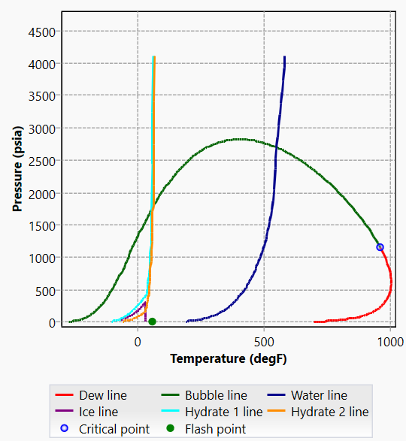

Figure . Mixture Fluid Phase Diagram

# Modeling and Analysis approach/methodology

## PIPESIM

The entire production and water injection field was modeled and analyzed using PIPESIM software. PIPESIM is a steady-state simulation software provided by Schlumberger that allows a wide variety of calculations geared towards flow assurance modeling. PIPESIM allows multiple approaches to model the production field, including single branch and network models.

As an initial analysis of the field, the single branch approach was used for the simplicity and flexibility. Erosional velocity ratio was observed in single wells for different tubing and flowline diameter. In our design consideration, we were trying to use a generalized tubing and flowline diameter. Also, we tried to minimize the tubing diameter so that we have enough clearance for gravel pack to avoid screen erosion.

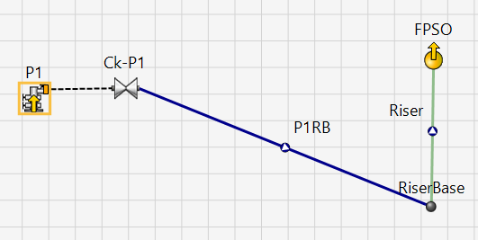

Figure . Single well analysis layout in Pipesim

Then we moved on to the comple field layout using the calculated reservoir pressure and given inputs at topside. The layout in Pipesim is as follows:

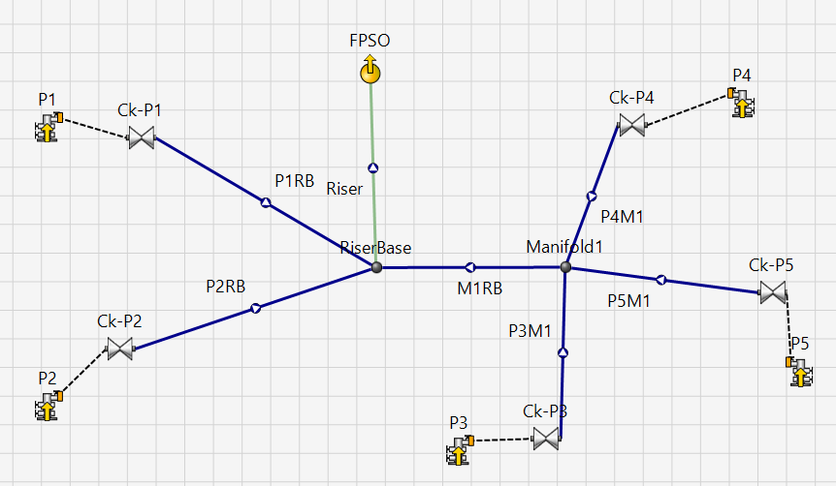

Figure . Production well analysis layout in Pipesim

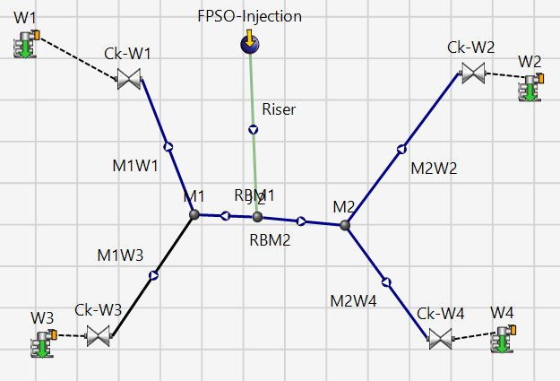

Figure . Water injection well analysis layout in Pipesim

Unlike production well and water injection, in chemical injection we were considering umbilicals which may be installed as S-lay, J-lay or Reel-lay. Chemical injection are ususally done near downhole when we are in the hydrate/wax formation region.

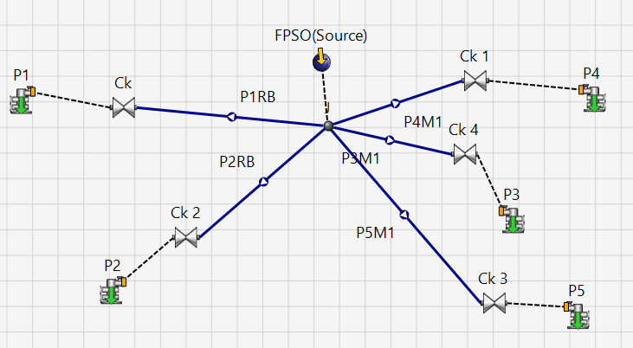

Figure . Chemical injection well analysis layout in Pipesim

## Overall approach

Various flow assurance strategies were considered and the field architecture was determined based on the corresponding flow assurance issue (i.e. optimized flowline length was the determining factor for manifold placement). Line sizing and choking were performed to match the given flowrates. This procedure was performed for early life, mid life, and late life.

For different line sizes erosional velocity ratio was observed and maintained below 1. After that choking was controlled to maintain the given flowrtes. This approach was adopted to design for avoiding gas lift. Some of the important aspects that were optimized were pressure losses (line diameter, line length) and erosional rate (from mean flow velocity). For thermal losses (insulation at various tubings, flowlines, and riser, mainly to avoid wax formation) constant U-value(2 Btu/hr-ft2-F) was used for all pipelines to avoid hydrates and was formation. Using PIPESIM’s performance analysis function, the sensitivity of these aspects to different system parameters (i.e. correlation of parameters to performance) could be visualized easily, as seen in the proceeding section.

### Pressure Drop in Tubing, Flowline, and Riser

One goal of the line sizing is to minimize the pressure loss due to friction as the flow originates from the well and travels towards the topside. Once the field geometry was set and the lengths were determined, the parameter to be determined was the line diameter.

### Production and Injection Choke Pressure Drop

In order to ensure that the incoming flow into the manifold arrive at the same pressure, chokes were used to lower the pressure of higher pressure wells so that their flow pressure matches that of the lower pressure wells. The bean size of chokes was the key parameter to be changed in this aspect. Chokes were applied at wellheads to maintain the required flowrates of oil.

### Thermal Losses

In order to avoid the deposits (wax, hydrates, asphaltenes, etc.), the flow of the oil and gas should stay within a certain range. Since only the wax appereance temperature (70 F) was given, that temperature was used as the minimum flow temperature. The key parameter to be modified for this is the thermal insulation of the tubing, flowline, and riser. Generally, the insulation had to be increased for lines that had unsatisfactory levels of thermal loss.

For water injection lines, thermal insulation was not necessary, as there is no possibility of deposits except for scales. Thus, the minimum amount of thermal insulation was used for water injection lines to lower costs. Section 5 includes graphs showing the change of temperature across the entire field.

### Erosional Study

By making sure that the fluid flow stays below an erosional rate, the longevity and safety of the system lines will be increased. From the given API 14E C-Factor (100), the line sizes were modified to ensure that the mean fluid velocity was below the erosional velocity. Where possible, the erosional velocity ratio was maintained at a low number to provide a safe margin and prevent erosional failure of the flowlines. In Section 5, the fluid mean velocity and erosional velocity ratio of each production flowline and riser is shown.

### Gas Lift Study

Gas lift has multiple effects on the flow assurance of the production system. The foremost effect is the modification of pressure, and its effects are quite pronounced as the field reaches late life. Secondary effects include the correlation of gas lift to slug volume and frequency. In this study, gas lift requirements were determined based on the amount of gas lift needed to boost pressure until the production fluids can reach topside. In our field layout with different choke size, no gaslift was required.

### Liquid Slugging

At late life due to high GOR and watercut(%) liquid slug is expected. So, we are considering finger slug catcher at topside to handle that issue.

# Analysis Results

## Early Life Analysis

For all production wells, the downhole pressures are 3200 psi, corresponding to various reservoir pressures (Table 3). From this value, the pressure dropped to pressure required at topside (190 psi). vertical drops are due to choking and change in diameter along the flow.

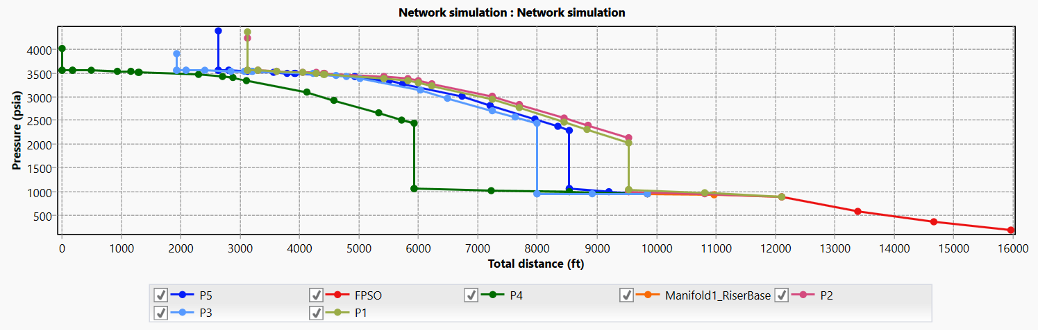

Figure . Production Wells Pressure vs Total Distance

The minimum temperature from fig-8 is observed above 70 F. So, we do not require any chemical injection for hydrate/wax formation.

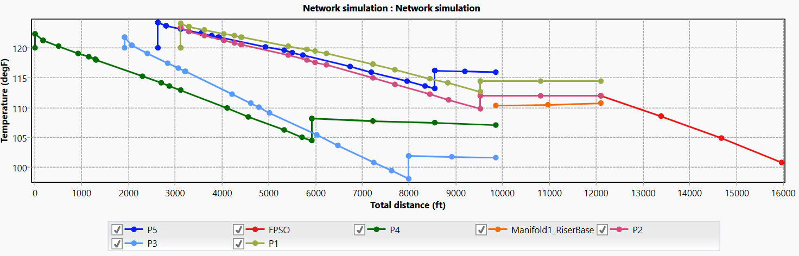

Figure . Production Wells Temperature vs Total Distance

Erosional velocity ratio in Fig-9 is below 1. So, fluid mean velocity is below erosional velocity along the pipeline for the selected line sizes.

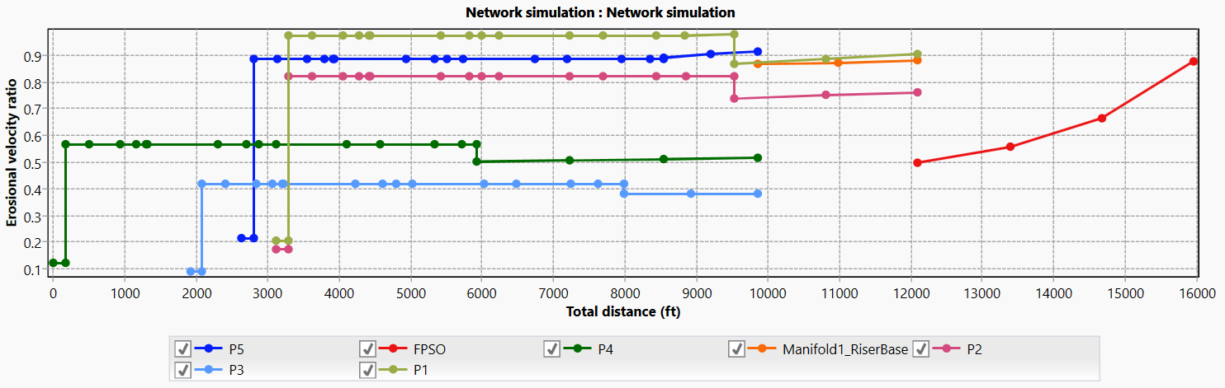

Figure . Production Well Erosional Velocity Ratio vs Total Distance

Fluid mean velocity along the pipeline are shown in Fig-10.

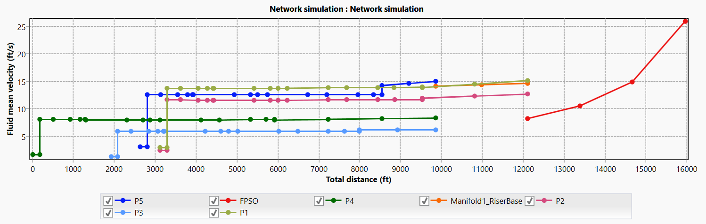

Figure . Production Well Fluid Mean Velocity vs Total Distance

Table-5 shows the pressure, temperature and flowrates for adjusted choke sizes at wells and junction points. The flowrates at wells matches given production well oil flowrates.

Table . Data from Pipesim simulation at early life production wells

|  |  |  |  |  |  |
| --- | --- | --- | --- | --- | --- |
| Name of Nodes | Pressure | Temperature | Q(oil) | Tube ID | Ck |
| psia | oF | stb/d | in | (1/64) |
| Manifold1 | 957.774 | 110.4213 | 29801.11 |  |  |
| RiserBase | 894.761 | 111.9782 | 56702.56 |  |  |
| FPSO | 190 | 100.8546 | 56702.56 |  |  |
| P1 | 2037.67 | 112.7196 | 14600.57 | 4 | 59.82 |
| P2 | 2140.43 | 109.8066 | 12300.89 | 4 | 54.26 |
| P3 | 2436.08 | 98.1185 | 6300.422 | 4 | 37.418 |
| P4 | 2442.31 | 104.4951 | 8500.422 | 4 | 43.461 |
| P5 | 2300.04 | 113.2721 | 15000.27 | 4.25 | 58.678 |

Fig-11 shows the presssure along the water injection flowline maintaining the given water injection flowrate and calculated FBHP. Here, two manifolds were used. Erosional velocity and insulation is not important as it is pure liquid flow through the flowlines.

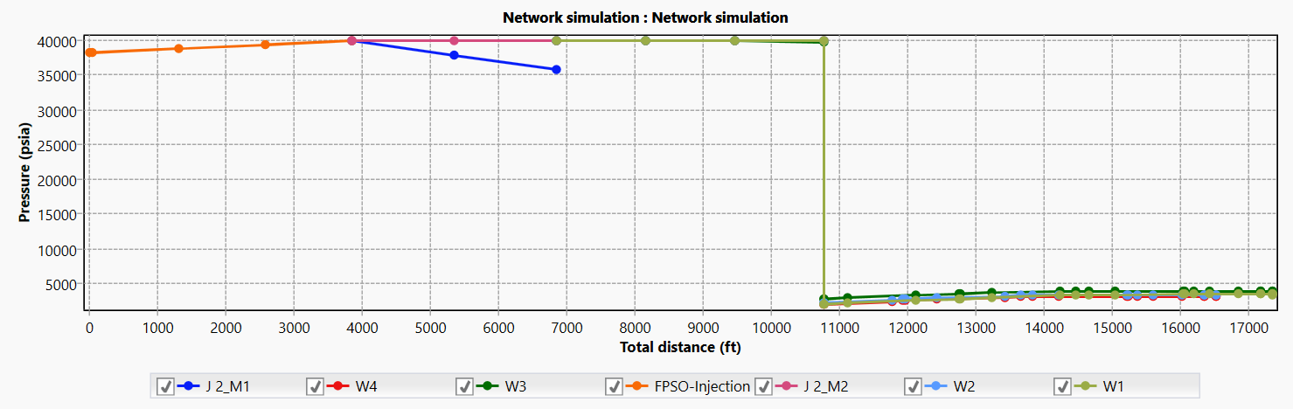

Figure . Water Injection Well Pressure vs Total Distance

## Mid Life Analysis

Similar to early life, for all production wells, the downhole pressures are 3200 psi, corresponding to various calculated reservoir pressures (Table 3). Here, we are using the same line sizes, but higher watercut(50%). The watercut is adjusted inn the fluid model.

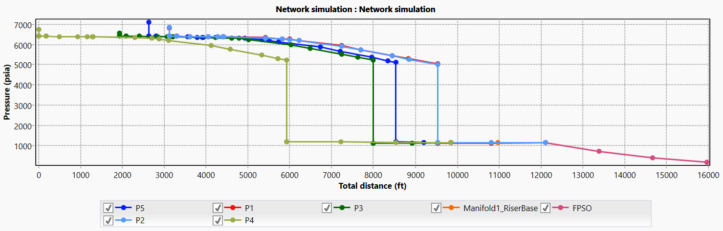

Figure . Production Wells Pressure vs Total Distance

The minimum temperature from fig-13 is observed above 70 F. So, we do not require any chemical injection for hydrate/wax formation.

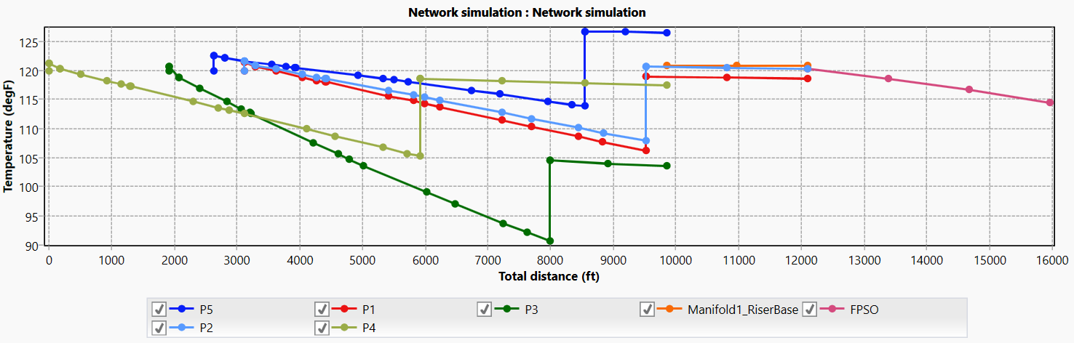

Figure . Production Wells Temperature vs Total Distance

Erosional velocity ratio in Fig-13 is below 1. So, fluid mean velocity is below erosional velocity along the pipeline for the selected line sizes.

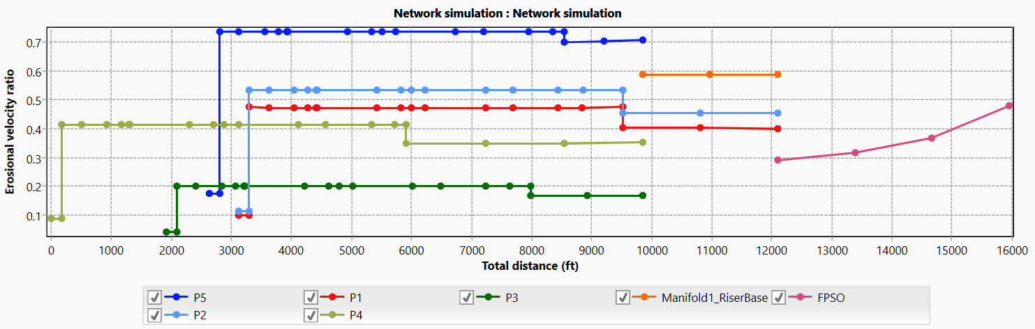

Figure . Production Well Erosional Velocity Ratio vs Total Distance

Fluid mean velocity along the pipeline are shown in Fig-15.



Figure . Production Well Fluid Mean Velocity vs Total Distance

Table-6 shows the pressure, temperature and flowrates for adjusted choke sizes at wells and junction points. The flowrates at wells matches given production well oil flowrates.

Table . Data from Pipesim simulation at early life production wells

|  |  |  |  |  |  |
| --- | --- | --- | --- | --- | --- |
| Name of Nodes | Pressure | Temperature | Q(oil) | Tube ID | Ck |
| psia | oF | stb/d | in | (1/64) |
| Manifold1 | 1149.73 | 120.7784 | 12201.58 |  |  |
| RiserBase | 1149.88 | 120.3275 | 20702.19 |  |  |
| FPSO | 190 | 114.4703 | 20702.19 |  |  |
| P1 | 5033.52 | 106.1944 | 4000.115 | 4 | 33.19 |
| P2 | 5008.51 | 107.9402 | 4500.496 | 4 | 35.34 |
| P3 | 5223.46 | 90.70606 | 1700.435 | 4 | 21.415 |
| P4 | 5234.74 | 105.2588 | 3500.794 | 4 | 30.74 |
| P5 | 5111.46 | 113.8621 | 7000.349 | 4.25 | 43.755 |

Fig-16 shows the presssure along the water injection flowline maintaining the given water injection flowrate and calculated FBHP. Here, two manifolds were used. Erosional velocity and insulation is not important as it is pure liquid flow through the flowlines.

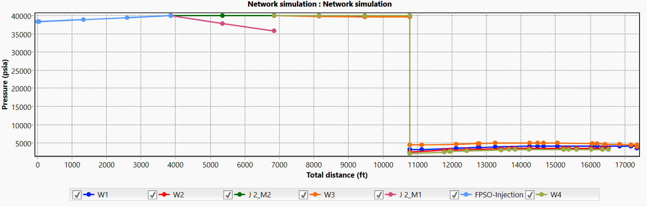

Figure . Water Injection Well Pressure vs Total Distance

## Late Life Analysis

Similar to early life, for all production wells, the downhole pressures are 3200 psi, corresponding to various calculated reservoir pressures (Table 3). Here, we are using the same line sizes, but higher watercut(80%). The watercut is adjusted inn the fluid model.

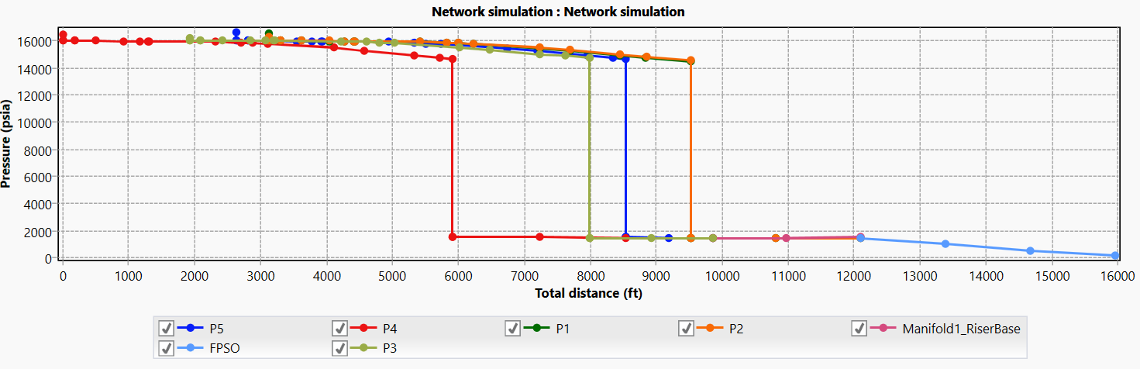

Figure . Production Wells Pressure vs Total Distance

The minimum temperature from fig-18 is observed above 70 F. So, we do not require any chemical injection for hydrate/wax formation.Reservoir temperature is 120 F and overall temperature is high due to the choking effect.

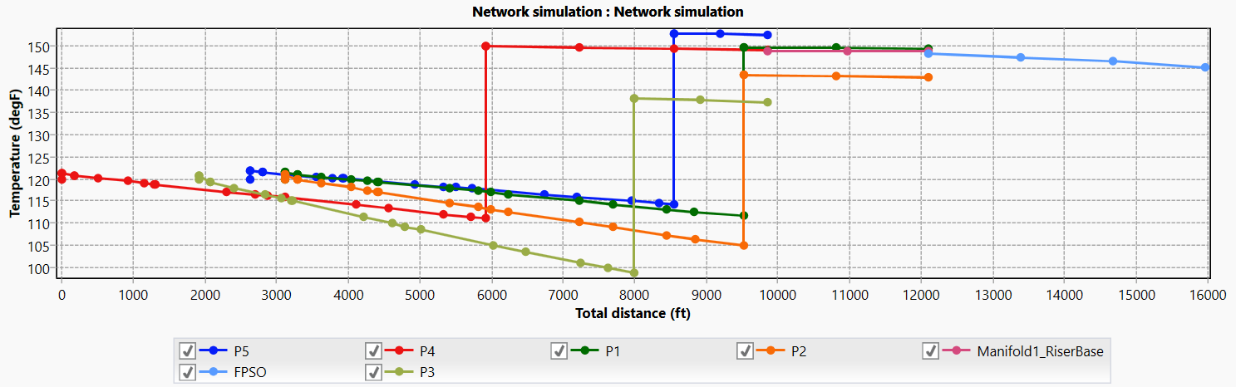

Figure . Production Wells Temperature vs Total Distance

Erosional velocity ratio in Fig-19 is below 1. So, fluid mean velocity is below erosional velocity along the pipeline for the selected line sizes.

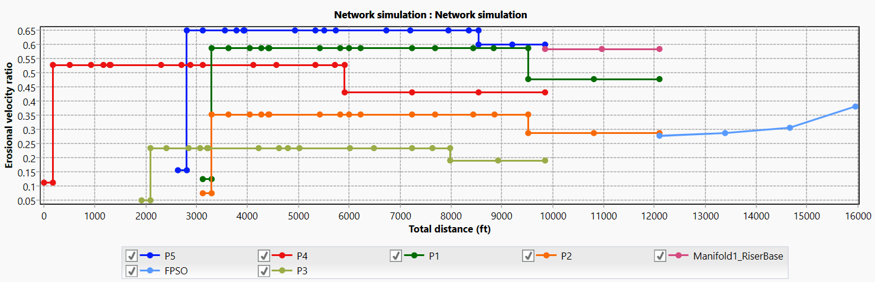

Figure . Production Well Erosional Velocity Ratio vs Total Distance

Fluid mean velocity along the pipeline are shown in Fig-20.

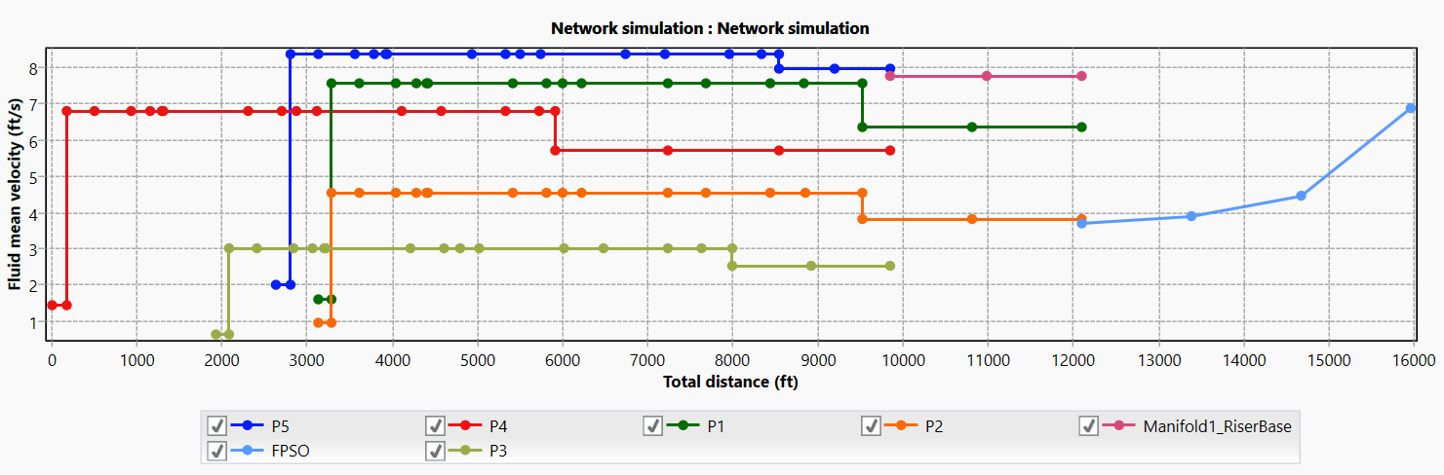

Figure . Production Well Fluid Mean Velocity vs Total Distance

Table-7 shows the pressure, temperature and flowrates for adjusted choke sizes at wells and junction points. The flowrates at wells matches given production well oil flowrates.

Table . Data from Pipesim simulation at early life production wells

|  |  |  |  |  |  |
| --- | --- | --- | --- | --- | --- |
| Name of Nodes | Pressure | Temperature | Q(oil) | Tube ID | Ck |
| psia | oF | stb/d | in | (1/64) |
| Manifold1 | 1492.41 | 148.9275 | 5100.398 |  |  |
| RiserBase | 1510.13 | 148.1864 | 8301.751 |  |  |
| FPSO | 190 | 145.184 | 8301.751 |  |  |
| P1 | 14461.3 | 111.6792 | 2000.813 | 4 | 28.35 |
| P2 | 14564.7 | 104.8775 | 1200.54 | 4 | 21.97 |
| P3 | 14719.7 | 98.80578 | 800.1568 | 4 | 17.84 |
| P4 | 14689.4 | 111.1811 | 1800.012 | 4 | 26.783 |
| P5 | 14644.1 | 114.2139 | 2500.23 | 4.25 | 31.593 |

Fig-21 shows the presssure along the water injection flowline maintaining the given water injection flowrate and calculated FBHP. Here, two manifolds were used. Erosional velocity and insulation is not important as it is pure liquid flow through the flowlines.

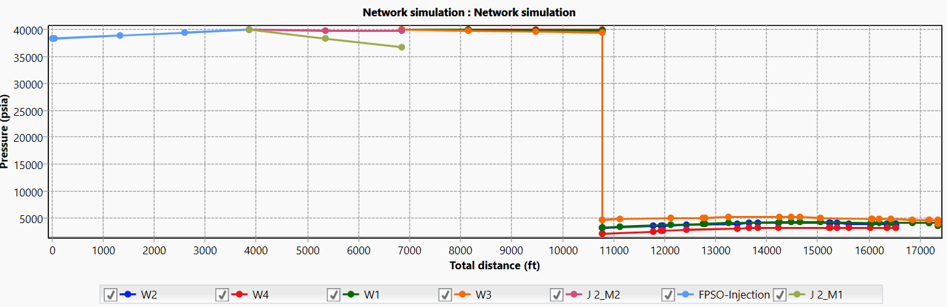

Figure . Water Injection Well Pressure vs Total Distance

# Recommendations

Changin the position of FPSO may lead to better performance. At late life, liquid slug is expected. So, adding a slug catcher at topside is recommended. Better design for easier pigging operation is recommended. Increasing the number of manifold for comparative study analysis is recommended.

# References

1. Young Bai and Qiang Bai, Subsea Engineering Handbook, Elsevier, Inc., 2010
2. Flow assurance class notes, University of Houston, spring 2013
3. Eduardo Buenrostro-Gonzalez, Carlos Lira-Galeana, Alejandro Gil-Villegas, Jianzhong Wu, “Asphaltene Precipitation in Crude Oils: Theory and experiments”, AIChE Journal, October 2004, Vol. 50, No.10
4. Jianzhong Wu, John M. Prausnitz, Abbas Firoozabadi, “Molecular thermodynamic of asphaltene precipitation in reservoir fluids”, AIchE Journal, January 2000, Vol. 46, No. 1
5. ASM Handbook, Vol. 13A, Corrosion: fundamentals, testing and protection, 2003, pp 236–241
6. ASM Handbook, Vol. 13A, Corrosion: fundamentals, testing and protection, 2003, pp 242–247
7. ASM Handbook, Vol. 18, Friction, Lubrication, and Wear Technology, 1992, pp 199–213